GLOBAL SALES AND FINANCIAL PERFORMANCE
DASHBOARD

Using Microsoft Power BI
Project Report

Submitted By
Name:Niveditha Aanand
Roll No.: E25FA059
Tool Used: Microsoft Power BI Desktop

1. Introduction
This project consists of a Global Sales & Financial Performance Dashboard made using Microsoft Power BI. The dashboard makes use of KPI cards, graphs, tables and slicers in order to derive insights from the sales transaction data.
The report includes sales, cost, profit and quantity. In addition to that, the analysis is done on the basis of categories, months, regions and employees.
2. Objectives
• Analyze performance in terms of total sales, cost, profit and quantity.
• To develop an interactive sales and financial dashboard using Microsoft Power BI. • To compare total sales of different product categories. Review the sales patterns by month and by region.
• To find out the employees who are contributing relatively higher profits.
• Show sales, profit and quantity information at product level.
• To enable filtering by year, product category and area.
3. Dataset Description
The dashboard is developed on a dimensional based Power BI model.It contains tables such as DimCustomer, DimDate, DimEmployee, DimGeography, DimProduct and FactSales. These tables help in analysis of customers, dates, employees, geography, products and sales transactions.
The report shows the key business indicators such as Total Sales, Total Cost, Total Profit, Total Quantity, Order Count and Average Sales.
4. Data Preparation
• Imported the sales model into Microsoft Power BI Desktop.
• Cleaned the data
• Used product, date, employee and geography dimensions for analysis.
• Prepared KPI cards and added graphs
• Created a dshboard with different visuals and slicers.
5. DAX Measures Used
DAX measures were used to calculate the key business indicators displayed in the KPI cards, product table and analytical visuals.
Measure / Indicator | Purpose
Total Sales | Calculates the total sales value across the sales data.
Total Cost | Shows the total cost associated with the sales.
Total Profit | Calculates the profit generated from sales.
Total Quantity | Shows the total quantity sold.
Order Count | Counts the orders or records represented in the report.
Average Sales | Calculates the average sales value represented in the dataset.
6. Dashboard Components
The report is organised into KPI cards, graphs, slicers .It includes DAX validation, KPI cards, visualisation, dashboard and sales tooltip .
A. KPI Cards
• Total Sales: 70.64M
• Total Cost: 45.52M
• Total Profit: 25.12M
• Total Quantity: 300K
• Average Sales: 706.36
These values summary of the important insights of the business position followed by the detailed charts and filters.
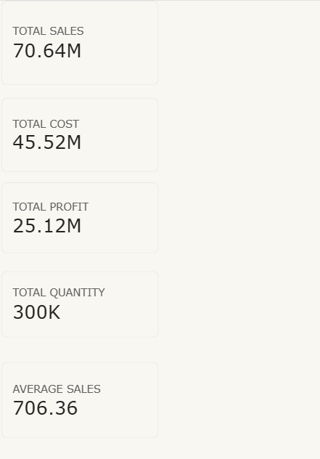
B. Table
The table shows Product Name, Total Quantity, Total Profit, and Total Sales. The total sales are about 70.64M and total profit is about 25.12M.
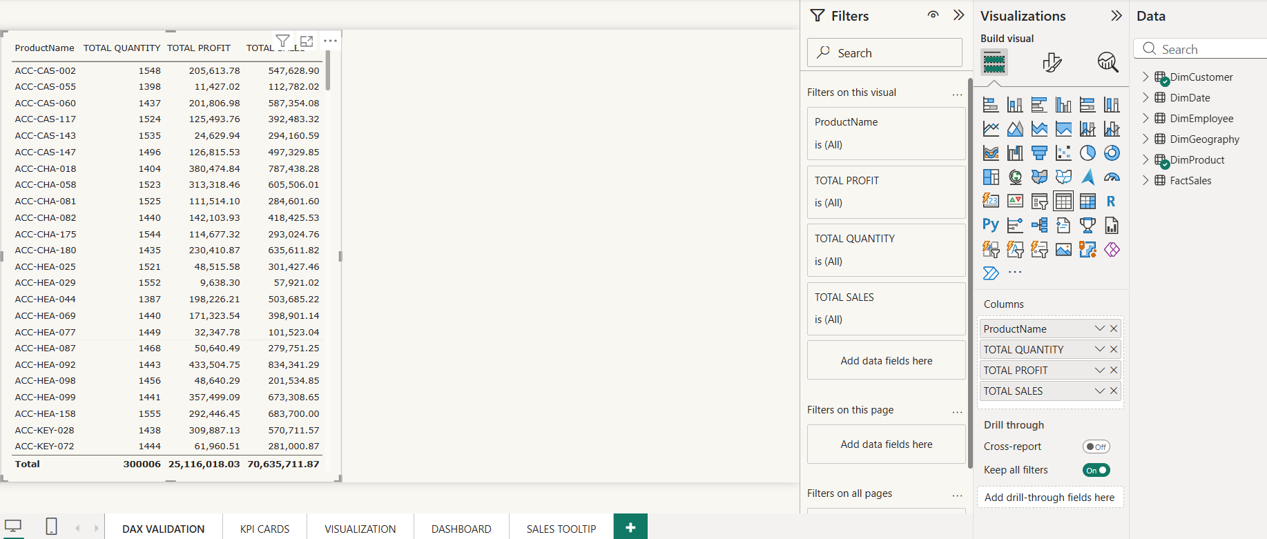

9. Visualisations
A. Total Sales by Category
The column chart compares total sales across six categories: Clothing, Accessories, Kitchen, Electronics, Outdoors and Furniture. In the displayed view, Clothing records the highest sales, while Outdoors and Furniture are among the lower categories.
B. Monthly Total Sales
The line chart presents total sales by MonthName, with the highest value around 6.2M and the lowest around 5.6M.
C. Total Profit by Employee
The horizontal bar chart compares employee-wise total profit, helping users identify employees with relatively high profit contribution.
D. Total Sales by Region
The donut chart displays sales across Central, South, West, North and East. The regional distribution is broadly balanced, with each region contributing close to one-fifth of the displayed total.
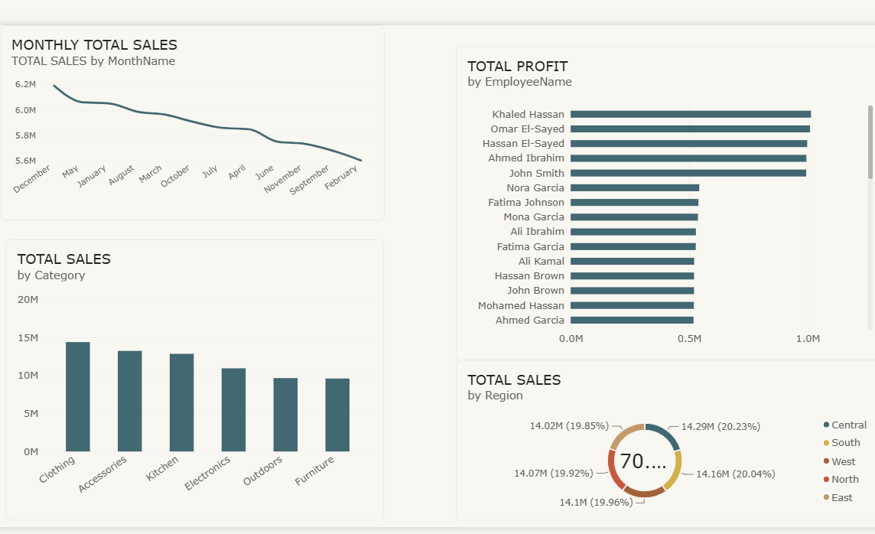

10. Dashboard
The final dashboard provides a single page of the key analytical components. In the upper part we have KPI cards, in the middle we have analysis by category and month, and in the lower part we have profit of employees and sales by region. On the right you have slicers and the product level table.
This setup allows for a summarized analysis and also a detailed study.The filters can be used to drill down into a selected year, product category or region.
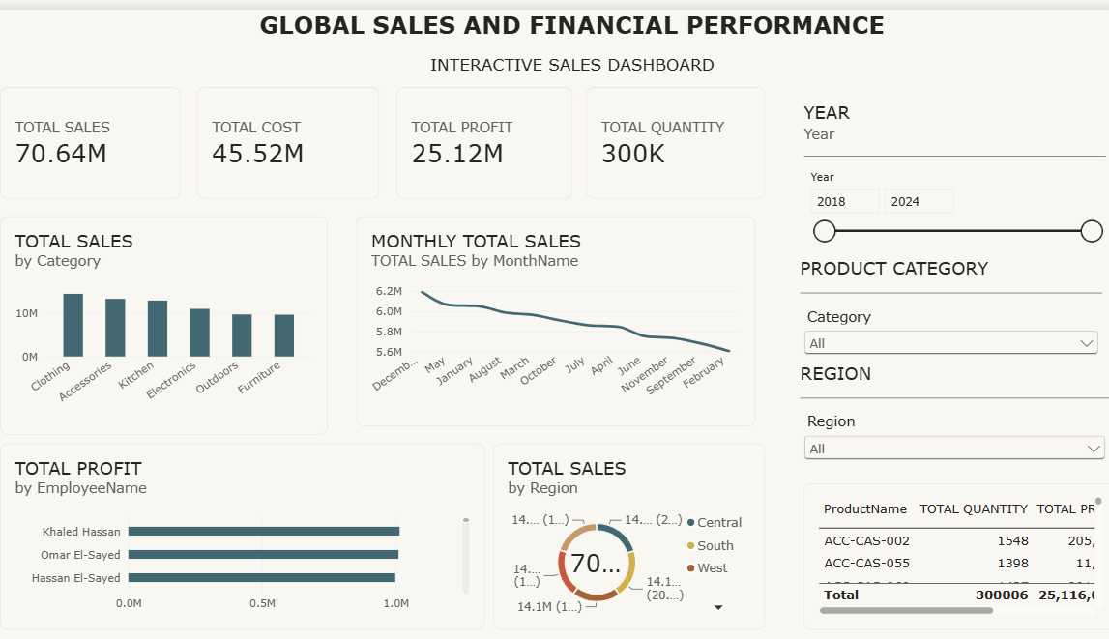
Figure 4: Final interactive dashboard with KPI cards, charts, slicers and product-level details.
11. Slicers
• Year: focuses on a selected year or a year range.
• Product Category: allows category-specific sales and profit analysis.
• Region: allows comparison between regions and product analysis.
When a slicer is selected, the visuals can update according to the selected slicer.
12. Key Findings
• The dashboard reports approximately 70.64M in total sales.
• Total cost is approximately 46M, while total profit is approximately 25.12M.
• Total quantity is approximately 300K and the order count is approximately 100K.
• Clothing is the largest sales category in the displayed category chart.
• Employee-wise profit varies, with the highest visible employees reaching close to the 1M scale.
• The month-wise sales chart shows variation between approximately 5.6M and 6.2M in the displayed view.
• The product table supports detailed comparison of individual products using sales, profit and quantity measures.
• The slicers make it possible to analyse the report by year, product category and region.
- Conclusion
The dashboard turns sales data into an interactive report using Power BI. It combines KPI cards with charts on categories and months along with employee profit analysis and regional sales distribution. Product level details come through as well and slicers help with filtering.
There are KPI cards to start and then graphs focusing on different contexts including slicers to get a more concise veiw of the data . It provides a framework for monitoring performance.
14. References
• Microsoft Power BI Desktop.
• Power BI data model containing DimCustomer, DimDate, DimEmployee, DimGeography, DimProduct and FactSales.

